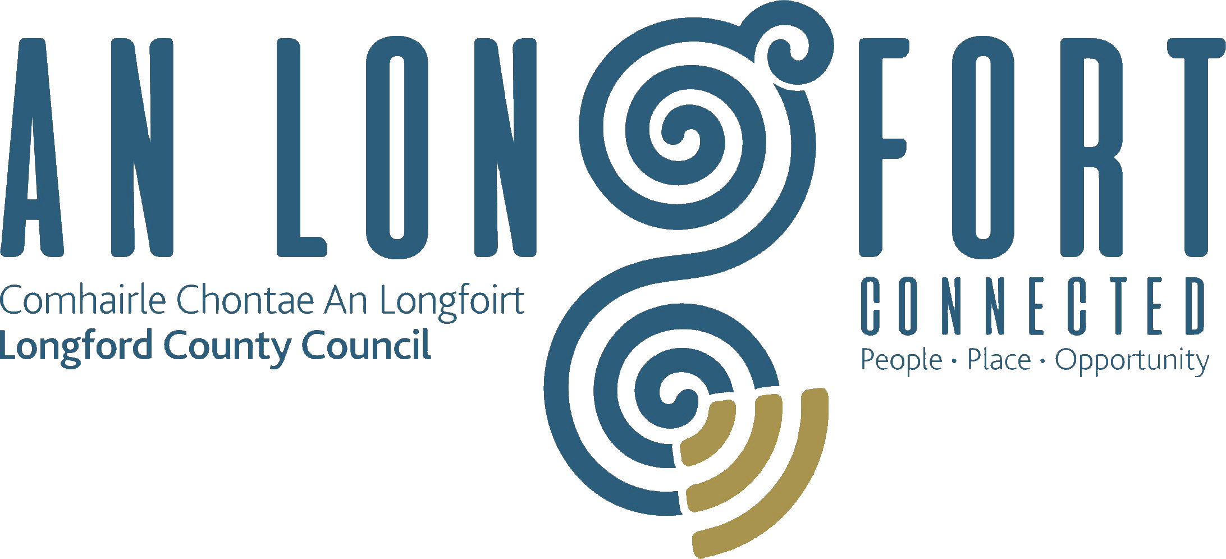

Minutes of Joint Policing Meeting held in the Council Chamber,
Aras an Chontae, Longford on
Monday, 3rd December 2018 at 3.00 p.m.

PRESIDING: Councillor Gerry Warnock

PRESENT: Councillors - Paraic Brady, Martin Mulleady,
Peggy Nolan, Pat O’Toole, Paul Ross, Paraic Brady, Seamus Butler, Gerard Farrell, and P.J. Reilly

Ms. Rosalind Greene and
Ms. Emma Kiernan

Mr. Paddy Mahon, Chief Executive
Ms. Barbara Heslin, Director of Services
Mr. Ciaran Murphy, Senior Executive Officer

Chief Supt. Tony Healy,
Inspector Blaithin Moran.
Supt. Brian Mohan

APOLOGIES:- Supt. Jim Delaney,
Councillors - John Browne Mick Cahill, Colm Murray, and Joe Flaherty,
Madeline Bennett, Peter Cox and Luke Casey

MEETINGS
ADMINISTRATOR: Anne Lee.

ADOPTION OF MINUTES.

On the proposal of Councillor P. O’Toole seconded by Supt. B. Mohan, it was unanimously agreed to adopt the minutes of Joint Policing Committee meeting held on the 10th September 2018, as circulated.

MATTERS ARISING.

CCTV

Councillor S. Butler stated that Longford MD have prepared a list of areas in Longford town where CCTV is required.
Property Marking Machine.

Councillor P. Ross proposed and Councillor S. Butler that Longford County Council purchase a Property Marking Machine.

GARDA REPORT

Inspector Moran briefed the members on the following and replied to queries raised –

- Statistics -
  - Burglaries.
  - Theft from vehicles.
  - Shop theft
  - Public Order incidents.
  - Crimes against persons.

- Ballymahon Multi-Cultural Event.
- Dead of Night event in Longford town.
- Open Day held at Longford Garda Station on the 22nd September.
- Operation Enable.

Inspector Moran acknowledged the support from Longford County Council towards the Garda Divisional Youth Achievement Awards.

Supt. Mohan briefed the members on the following and replied to queries raised –

- Statistics -
  - Burglaries.
  - Drugs offences.
  - Speeding incidents.
- Fatal Accident on the 13th October.
- Seizure of stolen property in Edgeworthstown.

Supt. Mohan emphasised the need for road safety, including safety of pedestrians. He also referred to the dangers of quad bikes and scramblers.

Supt. Mohan referred to a very successful event held in Granard Mart recently regarding farm safety, security etc.

Chief Superintendent Healy, Cathaoirleach Gerry Warnock and the members wished Supt. Mohan every health and happiness in his upcoming retirement and acknowledged his contribution to An Garda Siochana. P. Mahon, Chief Executive, on his own behalf and on behalf of the staff, also wished Brian a healthy and happy retirement.

Chief Superintendent Tony Healy also acknowledged the very successful JPC Public Meeting held in Ballymahon.

He thanked the public for their support in tackling crime and asked for continued assistance from the public to help the Gardai to deal with crime in the county.
LOCAL AUTHORITY REPORT

Mr. C. Murphy, Senior Executive Officer, updated the members on the following and replied to queries raised -

- Funding Programmes.
- Ballyminion Draft Masterplan.
- Camlin Quarter.
- Urban and Rural Regeneration and Development Fund.

Ciaran referred to the success of the 2018 JPC Public meeting which was held in Ballymahon Community Library on the 5th November, which was attended by –
- Commissioner Drew Harrris,
- Josephine Feehily, Chair of the Policing Authority,
- Sergeant Lionel Mullally, Garda Crime Prevention Officer,
- Conor O’Leary, Muintir na Tire,
- Kitty Hughes, Chairperson, Longford Older Persons Council and Crime Prevention Ambassador.

UPDATE ON LONGFORD JOINT ACTION PLAN

Mr. P. Mahon, Chief Executive, updated the members on the Pilot Programme for Ardnacassa Regeneration. He confirmed that most of the actions identified have either been addressed, completed or are in progress. It is proposed to engage with community reps early in 2019.

Drugs & Alcohol Forum Competition.

Councillor Warnock congratulated Moyne Community School winners of the County Longford Drugs & Alcohol Forum competition held recently to raise awareness of such issues as peer pressure, drink driving and impacts substance abuse can have on a person, their friends and families.

DATE OF NEXT MEETING

It was agreed that the next meeting be held on Monday, 4th March 2019.

This concluded the business of the meeting.

Signed:
Anne Lee,
Meetings Administrator.

Confirmed and adopted at Joint Policing Committee Meeting held on the
4th March 2019.

Signed: __________________
Chairperson.

